Project 1

<Black Jack>

CIS-5

Name: Junlong Wu

Date: 04/13/17

Introduction

Title: Black Jack

Blackjack, also known as twenty-one, is the most widely played casino banking game in the world. Blackjack is a comparing card game between a player and dealer, meaning players compete against the dealer but not against other players. It is played with one or more decks of 52 cards. The objective of the game is to beat the dealer in one of the following ways:

* Get 21 points on the player's first two cards (called a "blackjack" or “natural"), without a dealer blackjack;
* Reach a final score higher than the dealer without exceeding 21; or
* Let the dealer draw additional cards until his or her hand exceeds 21.

Summary

Project size: 168 lines

The number of variables: 8

It is my first time to do the project. It is really very hard for me. I took like one week to finish this program. When I wrote the code, I met so many problems, like sometimes even I lose, the program still doesn’t stop. I fix the bug again and again, and finally, I finished the program.

FlowChart Pseudo Code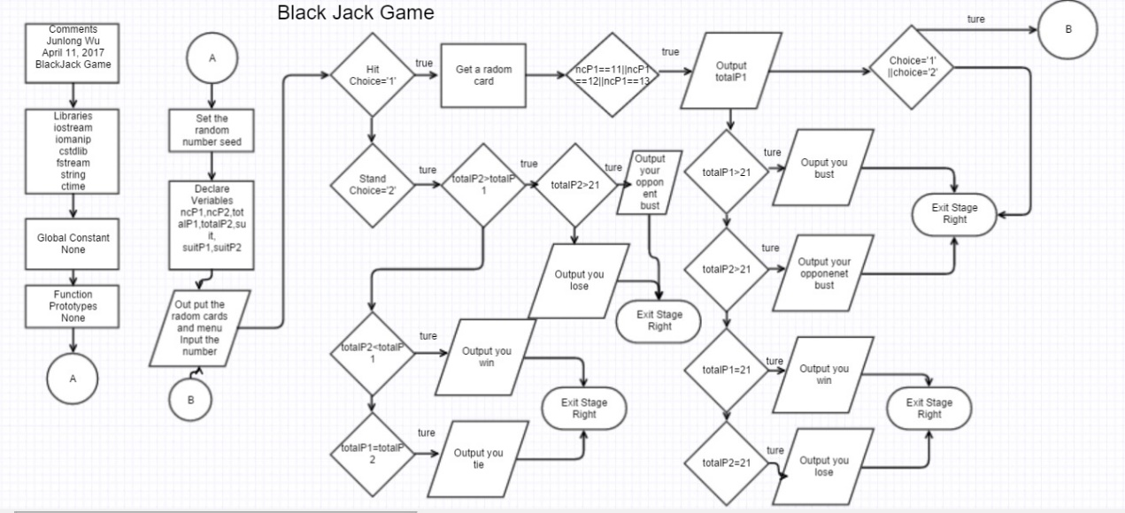

Program

//System Libraries

#include <iostream>

#include <iomanip>

#include <cstdlib>

#include <fstream>

#include <string>

#include <ctime>

using namespace std; //Name-space under which system libraries exist

//User Libraries

//Global Constants

//Function Prototypes

//Execution begins here

int main(int argc, char** argv) {

srand(static_cast<unsigned int>(time(0)));

int ncP1,ncP2,totalP1,totalP2,suit;

string suitP1,suitP2;

cout<<"Welcome to Black Jack game"<<endl;

cout<<"Your hand is"<<endl;

ncP1= rand()%13+1;

suit=rand()%4;

if (suit==0){

suitP1="diamond";

}

else if (suit==1){

suitP1="heart";

}

else if (suit==2){

suitP1="clover";

}

else if (suit==3){

suitP1="spade";

}

cout<<suitP1<<" "<<ncP1<<endl;

if (ncP1==11||ncP1==12||ncP1==13){

totalP1=10;

}

else {

totalP1=ncP1;

}

ncP1= rand()%13+1;

suit=rand()%4;

if (suit==0){

suitP1="diamond";

}

else if (suit==1){

suitP1="heart";

}

else if (suit==2){

suitP1="clover";

}

else if (suit==3){

suitP1="spade";

}

cout<<suitP1<<" "<<ncP1<<endl;

if (ncP1==11||ncP1==12||ncP1==13){

totalP1=10+totalP1;

}

else {

totalP1+=ncP1;

}

cout<<"The total is "<<totalP1<<endl;

totalP2=rand()%19+2;

char choice;

do{

cout<<"Type 1 to hit and type 2 to stand"<<endl;

cin>>choice;

switch(choice){

case '1':

ncP1= rand()%13+1;

suit=rand()%4;

if (suit==0){

suitP1="diamond";

}

else if (suit==1){

suitP1="heart";

}

else if (suit==2){

suitP1="clover";

}

else if (suit==3){

suitP1="spade";

}

cout<<suitP1<<" "<<ncP1<<endl;

if (ncP1==11||ncP1==12||ncP1==13){

totalP1=10+totalP1;

}

else {

totalP1+=ncP1;

}

cout<<"Your total is "<<totalP1<<endl;

if (totalP1>21) {

cout<<"You bust "<<endl;

cout<<"Your opponent's total is "<<totalP2<<endl;

exit(0);

}

if (totalP2<18) {

totalP2=totalP2+rand()%13+1;

if (totalP2>21){

cout<<"Your opponent bust, and you win "<<endl;

cout<<"Your opponent's total is "<<totalP2<<endl;

exit(0);

}

}

else if (totalP1==21) {

cout<<"You win "<<endl;

exit(0);

}

else if (totalP2==21) {

cout<<"Your opponent win "<<endl;

exit(0);

}

break;

case '2':

cout<<"Your opponent's total is "<<totalP2<<endl;

if (totalP1<totalP2) {

if (totalP2>21){

cout<<"Your opponent bust, and you win "<<endl;

exit(0);

}

cout<<"You lose "<<endl;

exit(0);

}

else if (totalP1>totalP2) {

cout<<"You win "<<endl;

exit(0);

}

else if (totalP1==totalP2) {

cout<<"You tie "<<endl;

exit(0);

}

break;

default:{

cout<<"You press the wrong number "<<endl;

return 0;

}

}

}while(1);

//Exit stage right!

return 0;

}